Rhombic Dodecahedron

Definition
# Source: AI Source: Provided by: [Data Path: Persons Table -> ID Column: 1, Name_En Column: Motasem Essam] -> From: [ChatGPT] on [7/25/2026]
A Rhombic Dodecahedron is a convex Catalan solid consisting of 12 congruent rhombus-shaped faces, 24 edges, and 14 vertices.
It is the dual polyhedron of the Cuboctahedron, an Archimedean solid.
Each face is a rhombus with two different diagonal lengths. The longer diagonal is exactly $\sqrt{2}$ times the shorter diagonal.

Simple Definition
# Source: AI Source: Provided by: [Data Path: Persons Table -> ID Column: 1, Name_En Column: Motasem Essam] -> From: [ChatGPT] on [7/25/2026]
A Rhombic Dodecahedron is a three-dimensional solid shaped like a diamond-faced polyhedron. It has 12 identical diamond-shaped faces joined together to form a closed solid.
It is called rhombic because its faces are rhombuses, and dodecahedron because it has 12 faces.
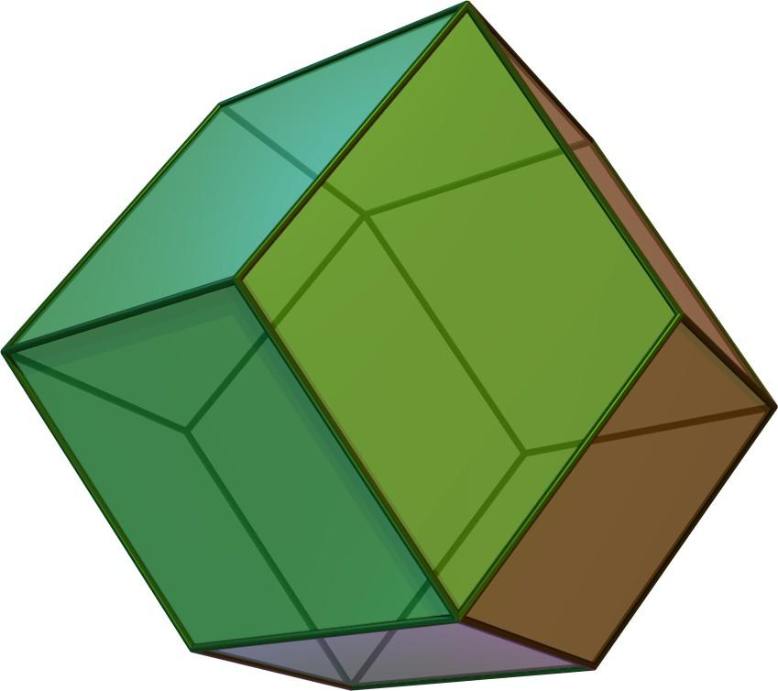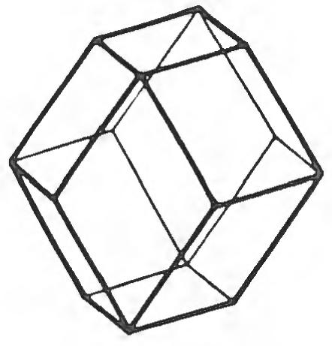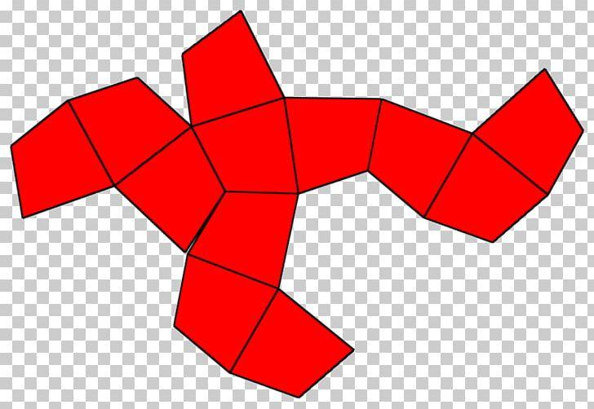

Geometric Structure
# Source: AI Source: Provided by: [Data Path: Persons Table -> ID Column: 1, Name_En Column: Motasem Essam] -> From: [ChatGPT] on [7/25/2026]
- It is a convex polyhedron.
- It has 12 congruent rhombic faces.
- The faces are arranged around 14 vertices.
- It has 24 edges, all equal in length.
- It has two different types of vertices.
- It has full octahedral symmetry.
- It can fill three-dimensional space without gaps or overlaps when repeated.

Face Structure
# Source: AI Source: Provided by: [Data Path: Persons Table -> ID Column: 1, Name_En Column: Motasem Essam] -> From: [ChatGPT] on [7/25/2026]
The Rhombic Dodecahedron has 12 identical rhombic faces.
Each face has:
- Four equal sides.
- Two pairs of equal opposite angles.
- Two diagonals of different lengths.
- Two acute angles and two obtuse angles.
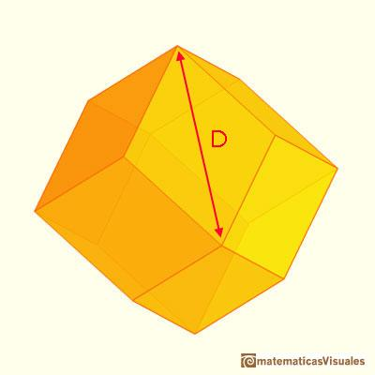

Face angles
# Source: AI Source: Provided by: [Data Path: Persons Table -> ID Column: 1, Name_En Column: Motasem Essam] -> From: [ChatGPT] on [7/25/2026]
- Acute angle: approximately ${70.53}^{°}$.
- Obtuse angle: approximately ${109.47}^{°}$.
The faces are congruent rhombuses, but they are not squares.

Edge Structure
# Source: AI Source: Provided by: [Data Path: Persons Table -> ID Column: 1, Name_En Column: Motasem Essam] -> From: [ChatGPT] on [7/25/2026]
The Rhombic Dodecahedron has 24 edges.
- All 24 edges have equal lengths.
- Every edge is shared by exactly two rhombic faces.
- The edges connect the two different types of vertices.
Unlike many Catalan solids, the Rhombic Dodecahedron is edge-transitive: its symmetries can map any edge onto any other edge.

Vertex Structure
# Source: AI Source: Provided by: [Data Path: Persons Table -> ID Column: 1, Name_En Column: Motasem Essam] -> From: [ChatGPT] on [7/25/2026]
The Rhombic Dodecahedron has 14 vertices, divided into two groups:
- 8 vertices of degree 3: Three rhombic faces meet at each vertex.
- 6 vertices of degree 4: Four rhombic faces meet at each vertex.
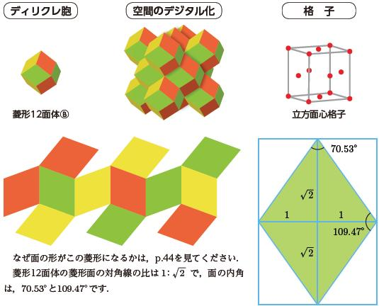
The eight degree-3 vertices correspond to the corners of an inscribed cube, while the six degree-4 vertices correspond to the vertices of an inscribed octahedron.

Mathematical Properties
# Source: AI Source: Provided by: [Data Path: Persons Table -> ID Column: 1, Name_En Column: Motasem Essam] -> From: [ChatGPT] on [7/25/2026]
12
Faces
24
Edges
14
Vertices
Euler's formula
$$V-E+F=2$$
$$14-24+12=2$$
The Rhombic Dodecahedron satisfies Euler's polyhedron formula.

Diagonal ratio
# Source: AI Source: Provided by: [Data Path: Persons Table -> ID Column: 1, Name_En Column: Motasem Essam] -> From: [ChatGPT] on [7/25/2026]
Let $d_{s}$ be the shorter diagonal and $d_{l}$ the longer diagonal of each rhombus.
$$\frac{d_{l}}{d_{s}}=\sqrt{2}$$
Therefore:
$$d_{l}=\sqrt{2} d_{s}$$

Dihedral angle
# Source: AI Source: Provided by: [Data Path: Persons Table -> ID Column: 1, Name_En Column: Motasem Essam] -> From: [ChatGPT] on [7/25/2026]
The interior angle between two adjacent face planes, measured inside the solid, is:
$${120}^{°}$$

Symmetry
# Source: AI Source: Provided by: [Data Path: Persons Table -> ID Column: 1, Name_En Column: Motasem Essam] -> From: [ChatGPT] on [7/25/2026]
The Rhombic Dodecahedron has full octahedral symmetry, represented by the symmetry group $O_{h}$.
Its symmetry includes:
- Four-fold rotational axes.
- Three-fold rotational axes.
- Two-fold rotational axes.
- Reflection planes.
- Inversion symmetry.
It is both face-transitive and edge-transitive, meaning all faces are interchangeable by symmetry, and all edges are interchangeable by symmetry. However, it is not vertex-transitive because it has two different vertex configurations.

Surface Area and Volume
# Source: AI Source: Provided by: [Data Path: Persons Table -> ID Column: 1, Name_En Column: Motasem Essam] -> From: [ChatGPT] on [7/25/2026]
Let $a$ represent the length of one edge.

Surface area
# Source: AI Source: Provided by: [Data Path: Persons Table -> ID Column: 1, Name_En Column: Motasem Essam] -> From: [ChatGPT] on [7/25/2026]
The area of one rhombic face is:
$$A_{f}=\frac{2\sqrt{2}}{3}a^{2}$$
Since there are 12 congruent faces:
$$SA=12A_{f}$$
$$\boxed{SA=8\sqrt{2} a^{2}}$$

Volume
# Source: AI Source: Provided by: [Data Path: Persons Table -> ID Column: 1, Name_En Column: Motasem Essam] -> From: [ChatGPT] on [7/25/2026]
The volume is:
$$\boxed{V=\frac{16\sqrt{3}}{9}a^{3}}$$
These formulas use the common edge length $a$ of the Rhombic Dodecahedron.

Relationship to Other Solids

Dual: Cuboctahedron
# Source: AI Source: Provided by: [Data Path: Persons Table -> ID Column: 1, Name_En Column: Motasem Essam] -> From: [ChatGPT] on [7/25/2026]
Rhombic Dodecahedron
Catalan solid
<icon name="arrow-left-right" size="xl"/>
Duality
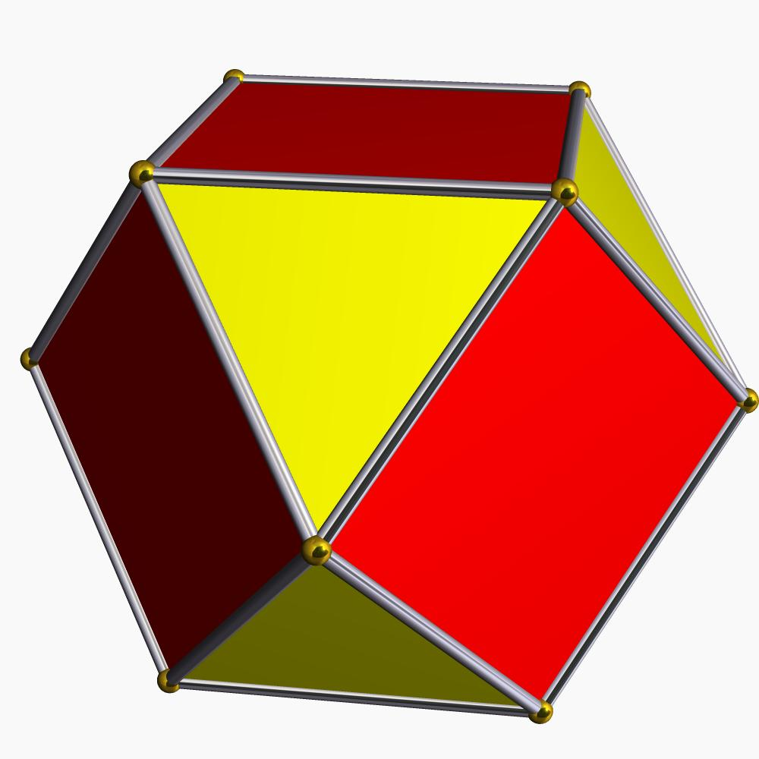
Cuboctahedron
Archimedean solid
The Rhombic Dodecahedron is the dual of the Cuboctahedron.
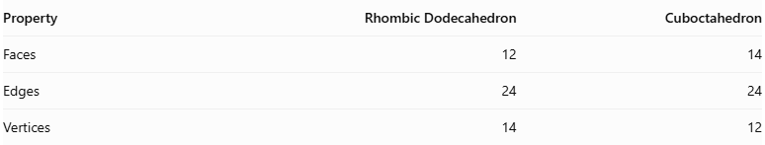
Property | Rhombic Dodecahedron | Cuboctahedron
Faces | 12 | 14
Edges | 24 | 24
Vertices | 14 | 12
In this dual relationship:
- The 14 faces of the Cuboctahedron correspond to the 14 vertices of the Rhombic Dodecahedron.
- The 12 vertices of the Cuboctahedron correspond to the 12 faces of the Rhombic Dodecahedron.
- Their 24 edges correspond to each other.

Space-filling property
# Source: AI Source: Provided by: [Data Path: Persons Table -> ID Column: 1, Name_En Column: Motasem Essam] -> From: [ChatGPT] on [7/25/2026]

An important property of the Rhombic Dodecahedron is that identical copies can fill three-dimensional space without leaving gaps or overlapping.
This makes it useful in studying space tessellations, crystal structures, and geometric packing.

Construction of Rhombic Dodecahedron

Geometric Instruments Used
# Source: AI Source: Provided by: [Data Path: Persons Table -> ID Column: 1, Name_En Column: Motasem Essam] -> From: [ChatGPT] on [7/25/2026]
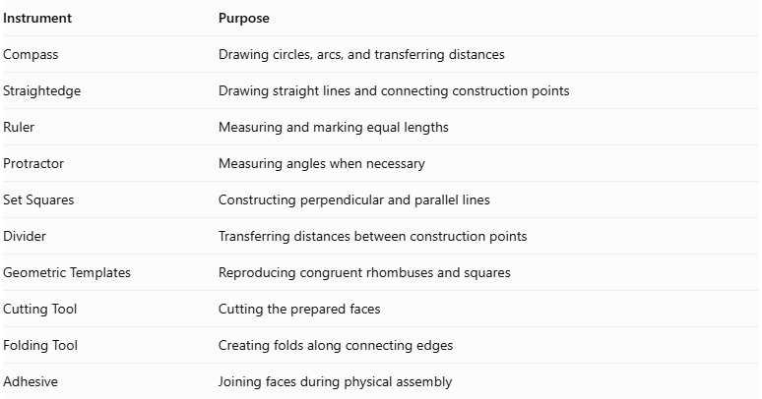
Instrument | Purpose
Compass | Drawing circles, arcs, and transferring distances
Straightedge | Drawing straight lines and connecting construction points
Ruler | Measuring and marking equal lengths
Protractor | Measuring angles when necessary
Set Squares | Constructing perpendicular and parallel lines
Divider | Transferring distances between construction points
Geometric Templates | Reproducing congruent rhombuses and squares
Cutting Tool | Cutting the prepared faces
Folding Tool | Creating folds along connecting edges
Adhesive | Joining faces during physical assembly

Instrument-Based Construction Procedures

Step 1: Construct the Central Cube
# Source: AI Source: Provided by: [Data Path: Persons Table -> ID Column: 1, Name_En Column: Motasem Essam] -> From: [ChatGPT] on [7/25/2026]
- Select a common cube edge length $a$.
- Draw a square using a ruler and straightedge.
- Construct perpendicular edges of equal length at the appropriate vertices.
- Complete the remaining square faces using parallel and perpendicular construction lines.
- Verify that all six faces are congruent squares.
- Check that all 12 cube edges have equal lengths.
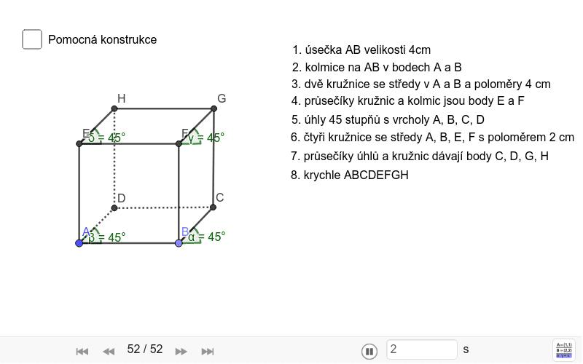

Step 2: Locate the Centers of the Six Cube Faces
# Source: AI Source: Provided by: [Data Path: Persons Table -> ID Column: 1, Name_En Column: Motasem Essam] -> From: [ChatGPT] on [7/25/2026]
- Select one square face of the cube.
- Draw its two diagonals using a straightedge.
- Mark their intersection as the face center.
- Repeat this process for all six faces.
- Verify that each center is equally distant from the four vertices of its square face.
These six face centers determine the positions of the six square pyramid apexes.
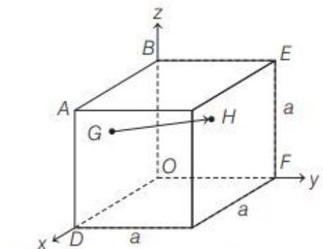

Step 3: Construct Perpendicular Lines Through the Face Centers
# Source: AI Source: Provided by: [Data Path: Persons Table -> ID Column: 1, Name_En Column: Motasem Essam] -> From: [ChatGPT] on [7/25/2026]
- Select one square face.
- Locate its center.
- Construct a line perpendicular to the face through its center.
- Extend the line outward from the cube.
- Repeat for the remaining five faces.
The six perpendicular lines define the directions of the attached pyramid apexes.

Step 4: Determine the Heights of the Square Pyramids
# Source: AI Source: Provided by: [Data Path: Persons Table -> ID Column: 1, Name_En Column: Motasem Essam] -> From: [ChatGPT] on [7/25/2026]
For a central cube with edge length $a$, each attached square pyramid must have a perpendicular height of:
$$h=\frac{a}{2}$$
- Set the ruler to half the cube's edge length.
- Measure this distance along each outward perpendicular line.
- Mark the apex position on each line.
- Repeat for all six cube faces.
The equal pyramid heights produce the standard rhombic dodecahedron.

Step 5: Construct the Square Pyramids
# Source: AI Source: Provided by: [Data Path: Persons Table -> ID Column: 1, Name_En Column: Motasem Essam] -> From: [ChatGPT] on [7/25/2026]
- Select one square face of the central cube.
- Identify its four vertices and its center.
- Mark the pyramid apex at the previously determined height.
- Connect the apex to the four vertices of the square base.
- Form four triangular lateral faces.
- Repeat for all six cube faces.
Each square pyramid contributes four triangular exterior sections.
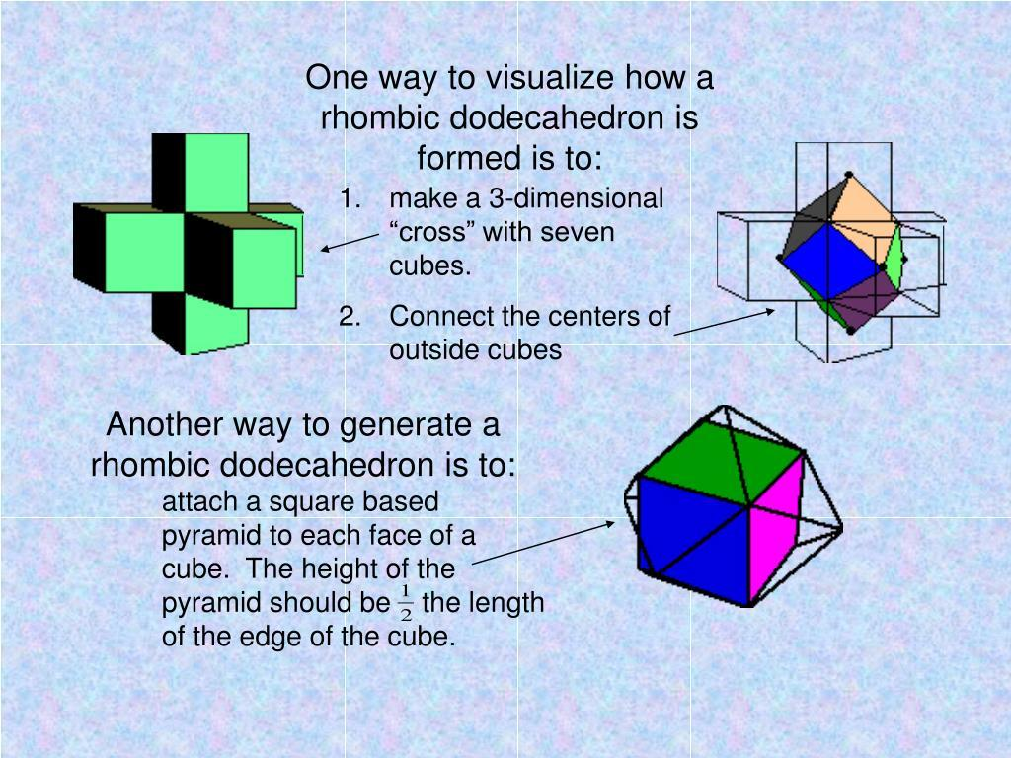

Step 6: Form the Twelve Rhombic Faces
# Source: AI Source: Provided by: [Data Path: Persons Table -> ID Column: 1, Name_En Column: Motasem Essam] -> From: [ChatGPT] on [7/25/2026]
- Examine the triangular lateral faces of adjacent square pyramids.
- Identify pairs of triangles sharing an edge of the original cube.
- Join each pair along its shared edge.
- Verify that the two triangles form one planar rhombus.
- Repeat for all 12 original cube edges.
- Confirm that the resulting solid has 12 congruent rhombic faces.
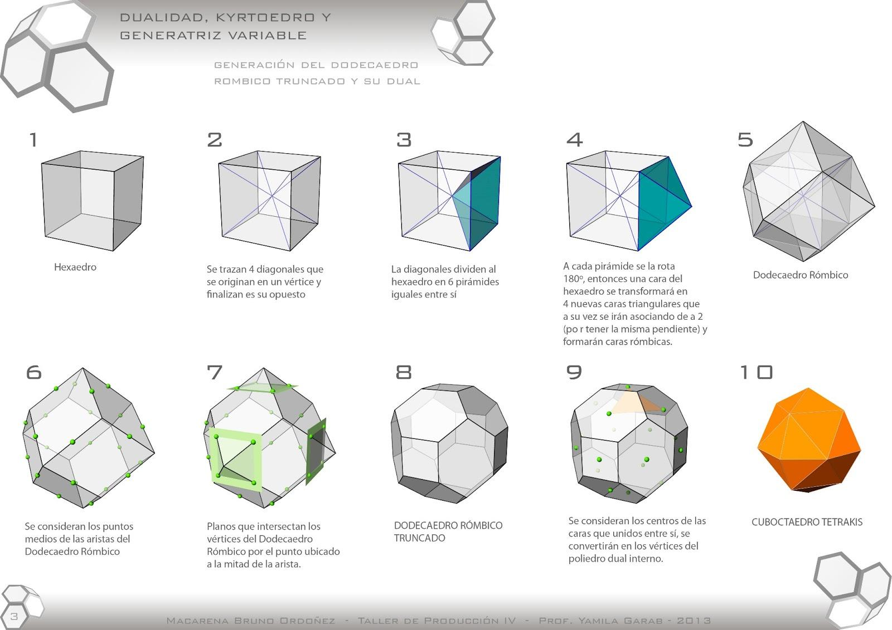

Step 7: Verify the Three-Dimensional Structure
# Source: AI Source: Provided by: [Data Path: Persons Table -> ID Column: 1, Name_En Column: Motasem Essam] -> From: [ChatGPT] on [7/25/2026]
- Check that all 12 faces are congruent rhombuses.
- Verify that all 24 edges have equal lengths.
- Confirm that eight vertices have valency 3.
- Confirm that six vertices have valency 4.
- Check that the completed solid is convex.
- Verify that the six pyramid apexes are arranged symmetrically around the central cube.
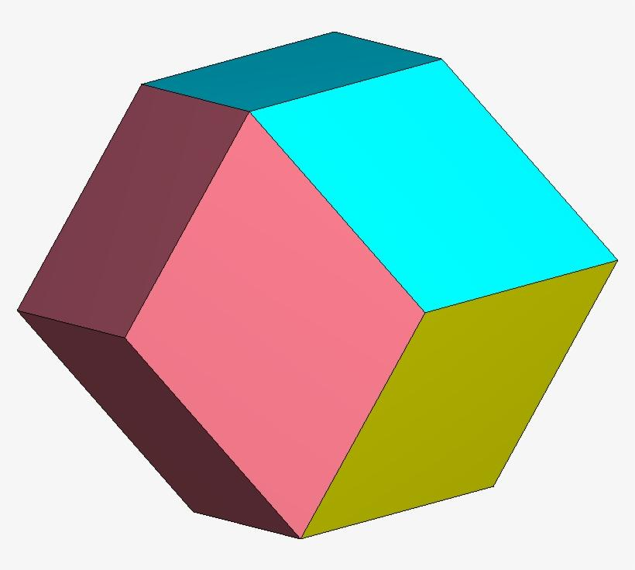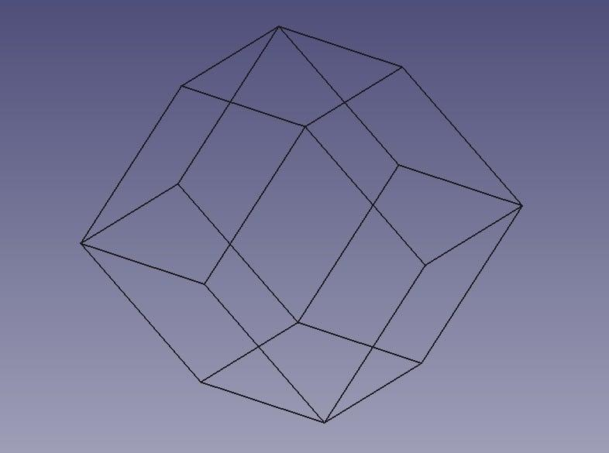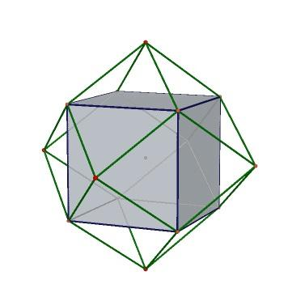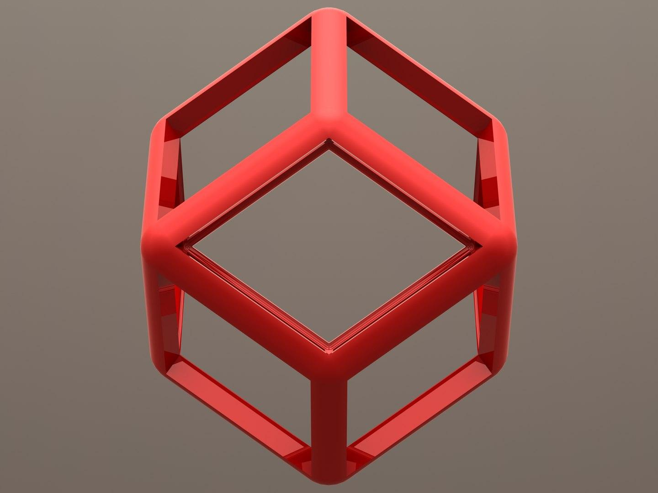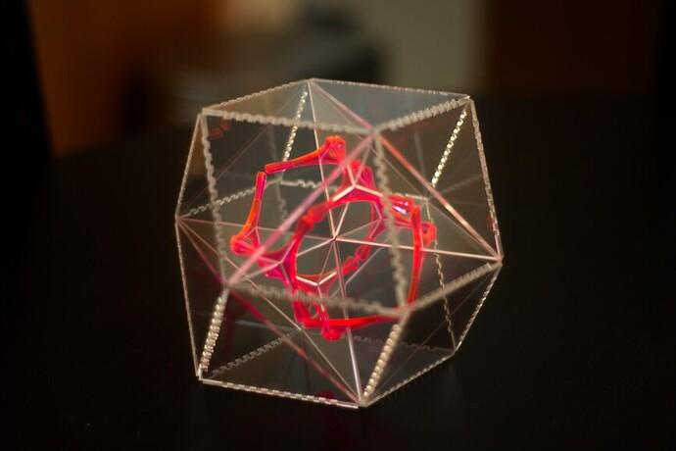

Step 8: Prepare the Faces for Physical Assembly
# Source: AI Source: Provided by: [Data Path: Persons Table -> ID Column: 1, Name_En Column: Motasem Essam] -> From: [ChatGPT] on [7/25/2026]
- Construct one accurate rhombus using a compass, ruler, and protractor.
- Set its interior angles to approximately ${70.53}^{°}$ and ${109.47}^{°}$.
- Reproduce the rhombus 12 times.
- Mark the shared edges according to a verified rhombic dodecahedron net.
- Cut out the faces and prepare joining tabs if necessary.
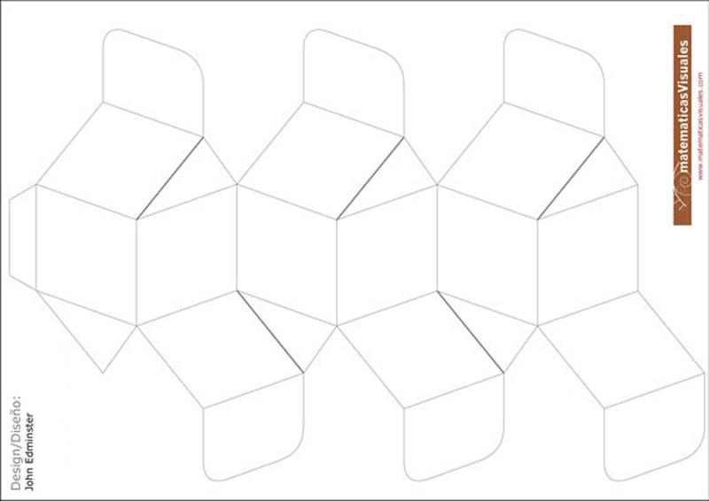

Step 9: Assemble the Three-Dimensional Solid
# Source: AI Source: Provided by: [Data Path: Persons Table -> ID Column: 1, Name_En Column: Motasem Essam] -> From: [ChatGPT] on [7/25/2026]
- Fold or position the 12 rhombic faces along their designated edges.
- Connect adjacent faces according to the verified net.
- Maintain the correct three-valent and four-valent vertex arrangements.
- Close the remaining openings.
- Inspect the completed solid for equal edge lengths and face congruence.
- Verify its overall octahedral symmetry.
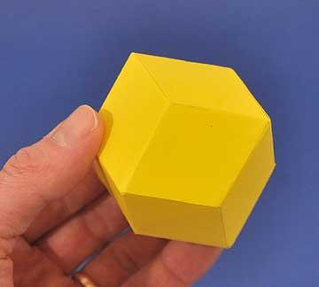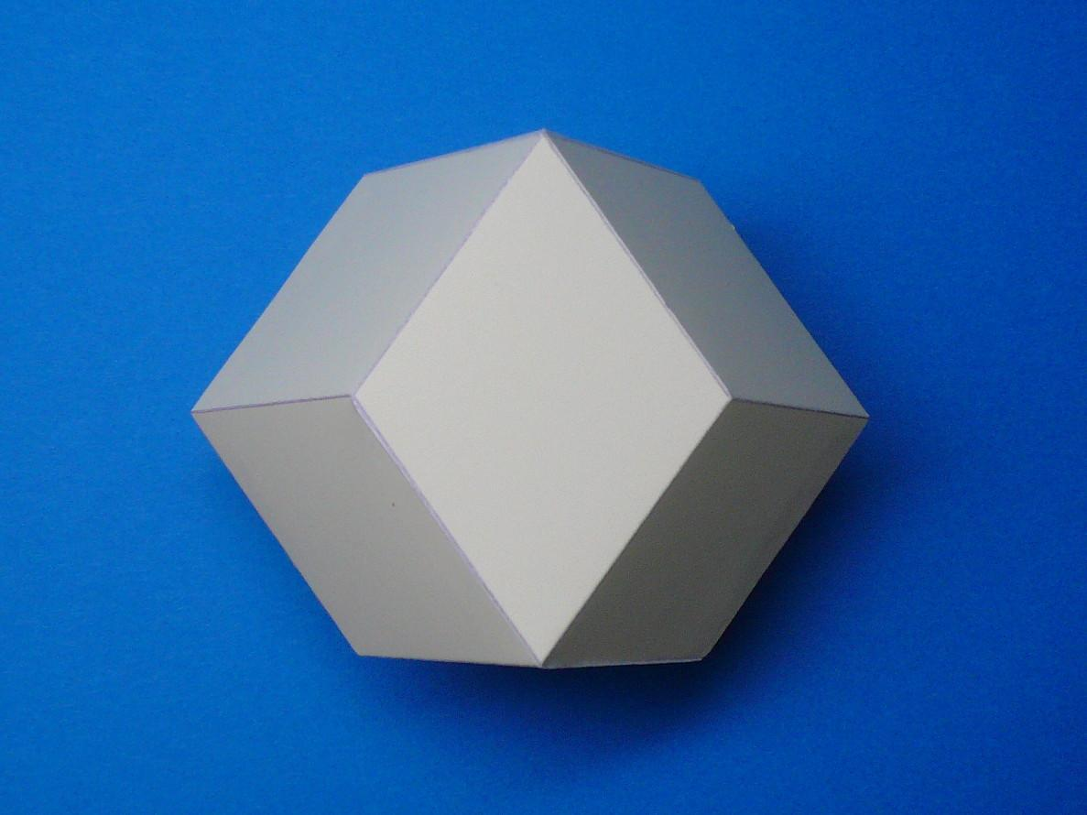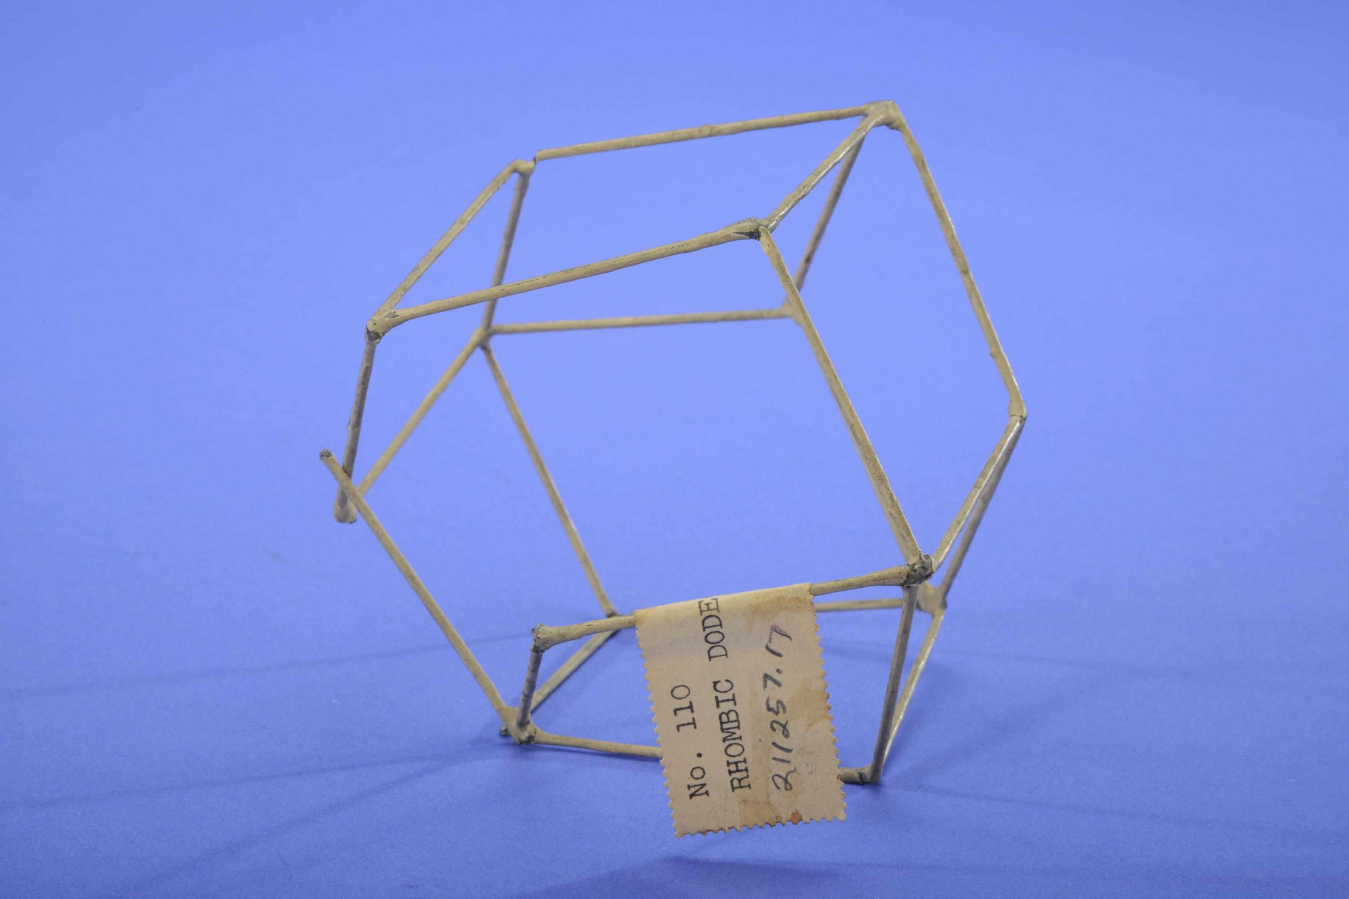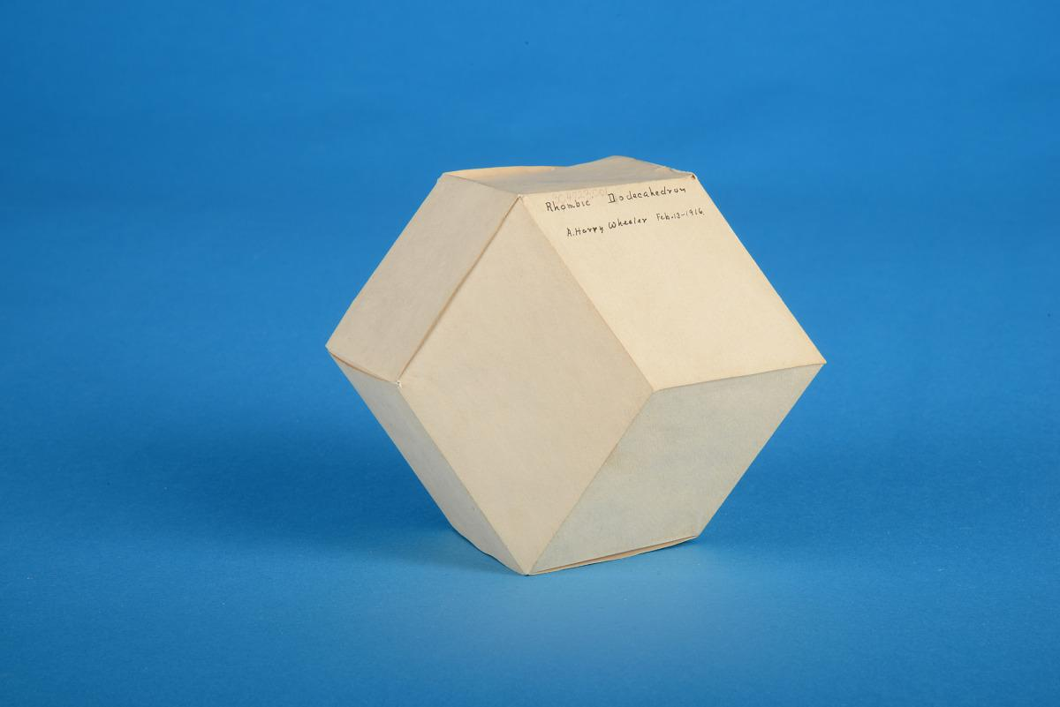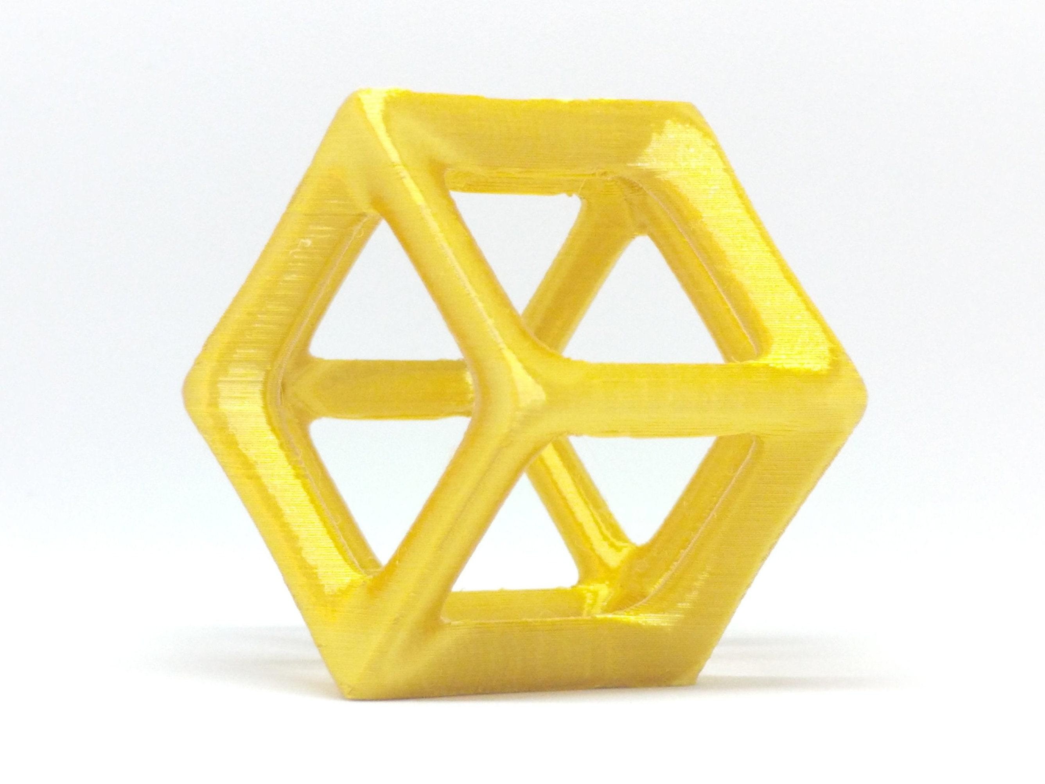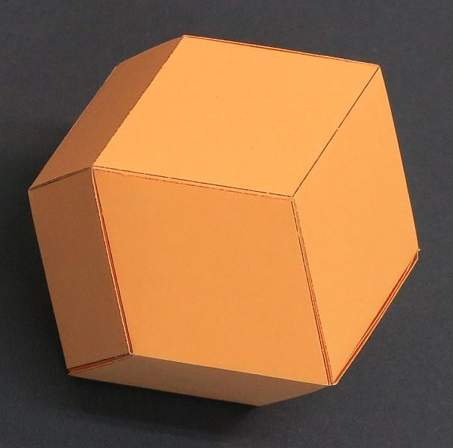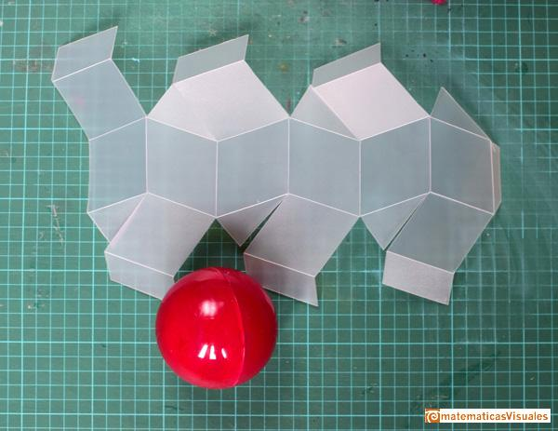

Constructing a Rhombic Dodecahedron in Solid Geometry
# Source: AI Source: Provided by: [Data Path: Persons Table -> ID Column: 1, Name_En Column: Motasem Essam] -> From: [ChatGPT] on [7/25/2026]
Required instruments:
- Ruler
- Compass
- Protractor
- Pencil
- Drawing paper
- Cardboard or construction paper for a physical model
Conceptual construction steps:
- Draw a regular Cuboctahedron.
- Identify the centers of its 14 faces.
- Use these face centers as the vertices of the dual polyhedron.
- Connect the centers of adjacent faces.
- Construct the 12 rhombic faces.
- Check that all 24 edges have equal lengths.
- Complete the solid and verify its symmetry.
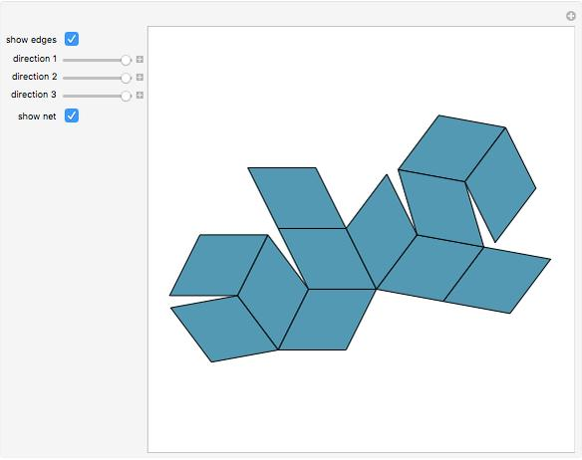

Key Points
# Source: AI Source: Provided by: [Data Path: Persons Table -> ID Column: 1, Name_En Column: Motasem Essam] -> From: [ChatGPT] on [7/25/2026]
- The Rhombic Dodecahedron is a Catalan solid.
- It has 12 congruent rhombic faces.
- It has 24 equal edges.
- It has 14 vertices.
- Eight vertices have degree 3.
- Six vertices have degree 4.
- Its face diagonals have a ratio of $1:\sqrt{2}$.
- Its interior dihedral angle is ${120}^{°}$.
- It is the dual of the Cuboctahedron.
- It has full octahedral symmetry.
- It can tessellate three-dimensional space.

Conclusion
# Source: AI Source: Provided by: [Data Path: Persons Table -> ID Column: 1, Name_En Column: Motasem Essam] -> From: [ChatGPT] on [7/25/2026]
The Rhombic Dodecahedron is an important member of the Catalan solids family. Its 12 congruent rhombic faces, 24 equal edges, and two different vertex configurations make it a distinctive convex polyhedron.
Its dual relationship with the Cuboctahedron and its ability to fill three-dimensional space make it particularly interesting in solid geometry, crystallography, and geometric modeling.

